Name:……………………………………………………………………………………………………………….

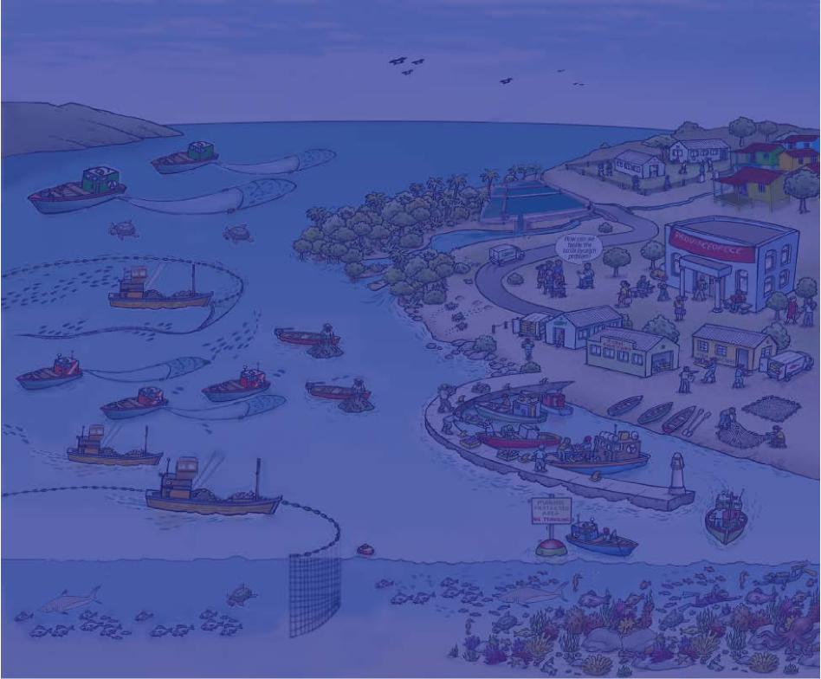
(Ecosystem Approach to Fisheries Management)
Essential EAFM
ACTION PLAN
BOOKLET
Version 1
Date:………………………………………. Place…………………………………………………………………………

Action Plan
Personal action plans for improved performance
What is action planning?
Action planning is an activity designed to assist you to achieve your goals by recognising and recording the tasks that need to be completed to reach your desired outcomes. Within the context of this training course, action planning is the first step in the implementation of your learning within the workplace.
Methodology
There is no single correct way to write individual action plans. The method of planning that you choose needs to be compatible with your personality and the context within which you work. What is critical, however, is that you have a blueprint that gives direction and focus to your activities. There is truth in the saying “if you fail to plan, you plan to fail”.
SMART is the key to a good action plan. It should specify who will do what, and by when. Using the same framework that we recommend for objective setting, keep your action planning:
Specific | An objective should be clear, understandable, unambiguous and focused on a single, specific aspect of the result. It indicates what you will do to produce results.  For each objective, you should identify a single key result.
Measurable | This describes what success looks like. It provides performance standards, which let you know whether you have achieved your objectives. Measures should be either:  - Quantifiable, i.e. contain a number, ratio or description which will make it clear when they have been achieved – typically describing quality, quantity, cost and time. For example, output, throughput, level of service delivery, cost reduction, reduction of work.  - Verifiable, i.e. specify who judges if the objective has been accomplished with agreed criteria or success factors that are used to make that judgement.
Achievable/ agreed | An objective should be challenging but within the reach of a competent and committed person. Not too easy and not too hard. It should be appropriate to the job holder’s needs and capabilities, and that of the department.  You need to agree your objectives with your manager so that you know you are talking about the same thing and are both committed to it. When you return to work after your workshop, be sure to share your prioritized action plan with your manager to ensure you have the support you need to achieve it.
Relevant | Use your department and team objectives as your starting point for considering your individual objectives. Consider how your new learning will help you achieve these objectives and future development goals.
Time-based | Must have an end date and preferably key milestones along the way. Deadlines help us focus our efforts, plan periodic review and ensure that everyone is aligned on expectations.

Developing an action plan does not mean that plans won’t change. You should review them regularly, both to monitor progress and to assess the need to modify them to cope with evolving circumstances and unforeseen events.

Action Plan
Implementing actions plans
Planning is never sufficient on its own. You also need the skills and commitment to translate these plans into development action. There is no substitute for experience, so be prepared for the development of your skills to take time and to learn from your mistakes. Also, be prepared to work with others who may have more experience/skills in a certain area to help you achieve your goals.
Action plan preparation
Use the following pages to record your planned actions during the course. After each training
session, complete the following boxes:
- Key skills learnt - the most useful learning points that you gained during the session.
- Application - how you plan to apply these key skills when you return to work
- End Result - the tangible (or sometimes intangible) results you expect to see; how you will know you have been successful
Recording this information helps you keep your learning focused and allows you to reflect on how you plan to transfer the knowledge and information learnt into practical application and results.
At the end of a course, you will be given time to reflect on the course as a whole. During this time, go through your completed action plan and select the areas that you would like to implement in the next 12 months and record it in the “Post Course Action Plan” at the back of the plan.
This Action Plan booklet is designed to help you move forward in your area of work. The more you use it during the course, the more benefit you will gain.

Action Plan
Date:___________________________________ Session_________________________________________________________
KEY SKILLS/KNOWLEDGE LEARNT |  | APPLICATION/SPECIFIC STEPS: I will do this... |  | END RESULT: So that...

Date:___________________________________ Session_________________________________________________________
KEY SKILLS/KNOWLEDGE LEARNT |  | APPLICATION/SPECIFIC STEPS: I will do this... |  | END RESULT: So that...

Date:___________________________________ Session_________________________________________________________
KEY SKILLS/KNOWLEDGE LEARNT |  | APPLICATION/SPECIFIC STEPS: I will do this... |  | END RESULT: So that...
Action Plan
Date:___________________________________ Session_________________________________________________________
KEY SKILLS/KNOWLEDGE LEARNT |  | APPLICATION/SPECIFIC STEPS: I will do this... |  | END RESULT: So that...

Date:___________________________________ Session_________________________________________________________
KEY SKILLS/KNOWLEDGE LEARNT |  | APPLICATION/SPECIFIC STEPS: I will do this... |  | END RESULT: So that...

Date:___________________________________ Session_________________________________________________________
KEY SKILLS/KNOWLEDGE LEARNT |  | APPLICATION/SPECIFIC STEPS: I will do this... |  | END RESULT: So that...
Action Plan
Date:___________________________________ Session_________________________________________________________
KEY SKILLS/KNOWLEDGE LEARNT |  | APPLICATION/SPECIFIC STEPS: I will do this... |  | END RESULT: So that...

Date:___________________________________ Session_________________________________________________________
KEY SKILLS/KNOWLEDGE LEARNT |  | APPLICATION/SPECIFIC STEPS: I will do this... |  | END RESULT: So that...

Date:___________________________________ Session_________________________________________________________
KEY SKILLS/KNOWLEDGE LEARNT |  | APPLICATION/SPECIFIC STEPS: I will do this... |  | END RESULT: So that...

Action Plan
Date:___________________________________ Session_________________________________________________________
KEY SKILLS/KNOWLEDGE LEARNT |  | APPLICATION/SPECIFIC STEPS: I will do this... |  | END RESULT: So that...

Date:___________________________________ Session_________________________________________________________
KEY SKILLS/KNOWLEDGE LEARNT |  | APPLICATION/SPECIFIC STEPS: I will do this... |  | END RESULT: So that...

Date:___________________________________ Session_________________________________________________________
KEY SKILLS/KNOWLEDGE LEARNT |  | APPLICATION/SPECIFIC STEPS: I will do this... |  | END RESULT: So that...
Action Plan
KEY SKILLS/KNOWLEDGE LEARNT |  | APPLICATION/SPECIFIC STEPS: I will do this... |  | END RESULT: So that...

KEY SKILLS/KNOWLEDGE LEARNT |  | APPLICATION/SPECIFIC STEPS: I will do this... |  | END RESULT: So that...

KEY SKILLS/KNOWLEDGE LEARNT |  | APPLICATION/SPECIFIC STEPS: I will do this... |  | END RESULT: So that...

Action Plan
Post-Course Action Plan
It is a good idea to put a note in your calendar to revisit your action plan after three, six and 12 months
Your name: ……………………………………………………………………………………………………………………………………
How are you planning to implement your learning in your work in the next 3 – 12 months?
Please note down 3 to 4 key action points you wish to implement in your workplace. These can be prioritized from your action plans on the previous pages.
Action | End result | Timescale | Support needed  (e.g. from your manager or  external sources)

Action Plan
Buddy follow up
This follow up is to help you implement the action plans you made here, despite the pressures of returning to daily work.
Choose a Buddy – someone who also attended the course – and agree to link up with them in approximately two weeks’ time. Set a provisional date and time now. You might even like to make it a regular discussion.
Ask each other how you are getting on with implementing your action plans. Below are some questions to help you get the conversation started.
Buddy name Contact details
Suggested questions:
- What were you planning to achieve from your action plan?
- Did you undertake the actions you decided on at the end of the workshop?
- If so, what was the result?
- How can you build on this learning going forward?
- If not, what stopped you and is it still worthwhile taking those actions? If so, what can you now do to make sure that you take the actions?

